William Meyer, Maurice Wilson, and Justin Apostle

CMSC 495

2/06/2022

**Table of Contents**

1. **Introduction 3**  
   1.1 Purpose 3  
   1.2 Scope 3  
   1.3 Overview 3
2. **File Structure Design**
3. **Data Structure**

**Project Design**

**Introduction**

**Purpose**

The purpose of this document is to provide details on the project management application created by Group 3. The information herein will describe the overall approach, design, and data structure of the application. This document will act as a reference to how the application will be structured based on the requirements from the project plan document. This document is geared towards program and project managers, scrum masters, students, and other professionals looking to manage personal or professional projects.

**Scope**

The project management application will provide an intuitive and simplified experience for task management. The application will allow managers to organize tasks in order of progress, priority, and completion. This application will streamline the users' experience in project management by focusing solely on task management and collaboration. Reporting will not be a function of the program as the focus of the application is for task management. By keeping the scope within the parameters just outlined, the user will be enabled to focus solely on progress of tasks and their projects.

**Overview**

The project manager will access the website through any modern web browser. Once the site is accessed, the user will login and be redirected to the dashboard with a list of their current projects. At this view, the user can select any number of currently created projects or create a new project. Once in a project, the user can manage their tasks from what is “In Progress,” to “Testing,” or even “Completed.” Additionally, the user can create new tasks or even delete already created tasks.

**File Structure Design**

Front end design with Bootstrap:

Bootstrap.min.js

Jquery-3.6.0.min.js

Script.js

InitializeBoards()

InitializeComponents(dataArray)

appendComponents(card)

togglePriority(event)

deleteCard(id)

removeClasses(cardBeingDragged)

save()

position(cardBeingDragged)

dragstart()

drag()

dragend()

dragover()

dragleave()

drop()

style.css

Back end design with Django:

ProjectManagementWebsite

projectApp

core

templates

base.html

create.html

dashboard.html

home.html

list.html

login.html

signup.html

_init_.py

admin.py

apps.py

forms.py

models.py

tests.py

views.py

settings.py

urls.py

wsgi.py

manage.py

**Data Structure**

Input information stored is based on the user and is stored to an SQL database. This information is later output from the same SQL database when called on. The SQL database will be hosted on a remote server meaning the user can access the information from anywhere with a modern web browser. Below is a concept map of the data structure for this application:

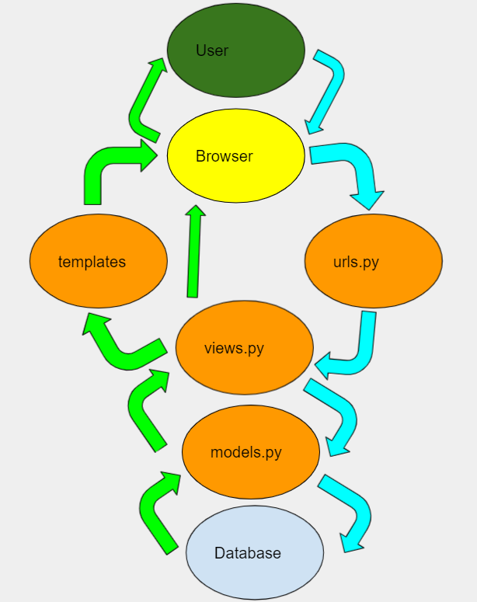  
*Figure 1*. Concept map for application.

**References**

(2022). Concept map for application [screenshot].